[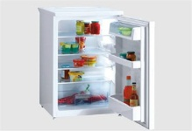](javascript:void(0);) [](javascript:void(0);)

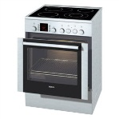 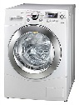 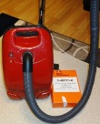

  

[](javascript:void(0);)

  

[](javascript:void(0);)

  

[](javascript:void(0);)

  

[](javascript:void(0);)

  